Examination requirements.

* We have to add name of the faculties -> already there in the admin panel but redesigning should be done
* Name of all the subjects semester wise. Including which subjects are theoretical and includes practical

Subjects can theories and/or practical.

* Faculty subject allocation should be done. Name of subject faculty and name of lab faculty.
* Name of the exams with their marks. i.e. unit test , internal test ( flexible )
* Calculation of internal marks bba and bca. bba – 30 bca -40

Bba – 8 ( unit ) 12 ( internal ) 5 ( assignment/seminar/presentation) 5 ( attendance - >

80>5,70-80-4,60-70:3,50-60:2,1)



Bca – 5 ( unit ) 10 int - ( practical sub ) 15 ( only theory ) , 5 ( assignment ) , 10 ( presentation / seminar

5 – attendance 5 – in case of practical subjects of internal practicals.

* Foundation course - 100 marks for each course bba and bca from sem 1 to sem 4
* Passing criteria – unit / internal 40%(should be dynamic )
* Results – result printout format
* Notice board printout for 30/40 marks calculations
* Block arrangement

Examination Module:

Home screen of examination module:

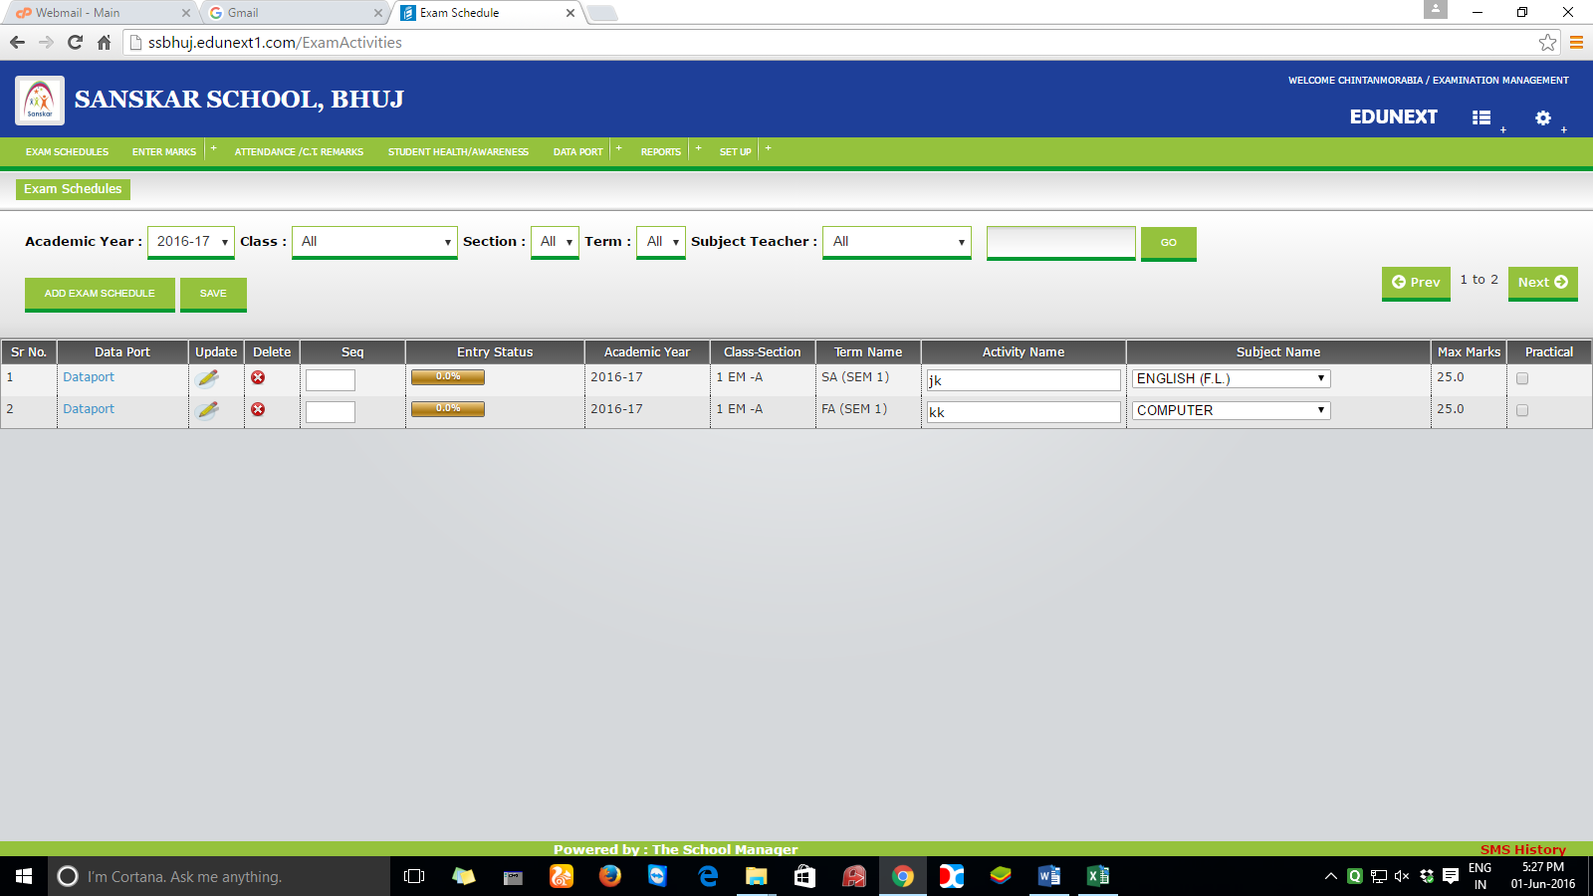

1. Add exam schedule Button :

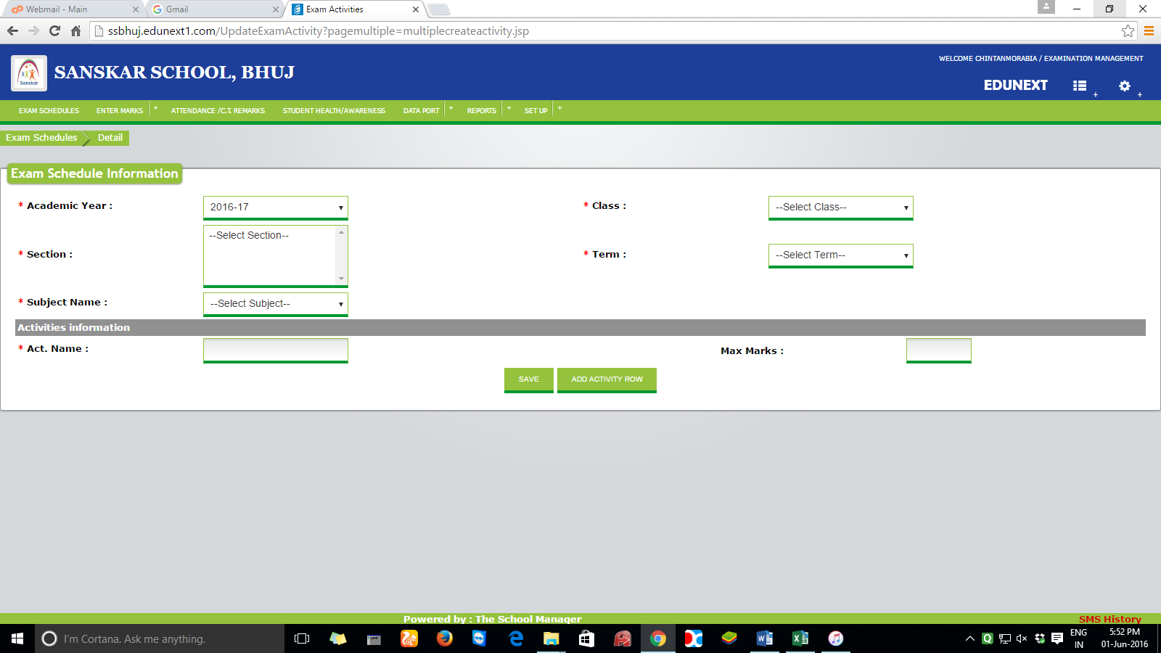

Following fields will be needed in the following order. Academic year , course, sem, div, subject name, term, act name(not mandatory) , max marks, Activity Date, Marks Submission Date.

Note : submission date is the date till which faculties can enter the marks from their login accounts.

1. Enter Marks Menu: (for admin and faculty login – admin login active only after faculty has submitted the marks)

Home Screen: 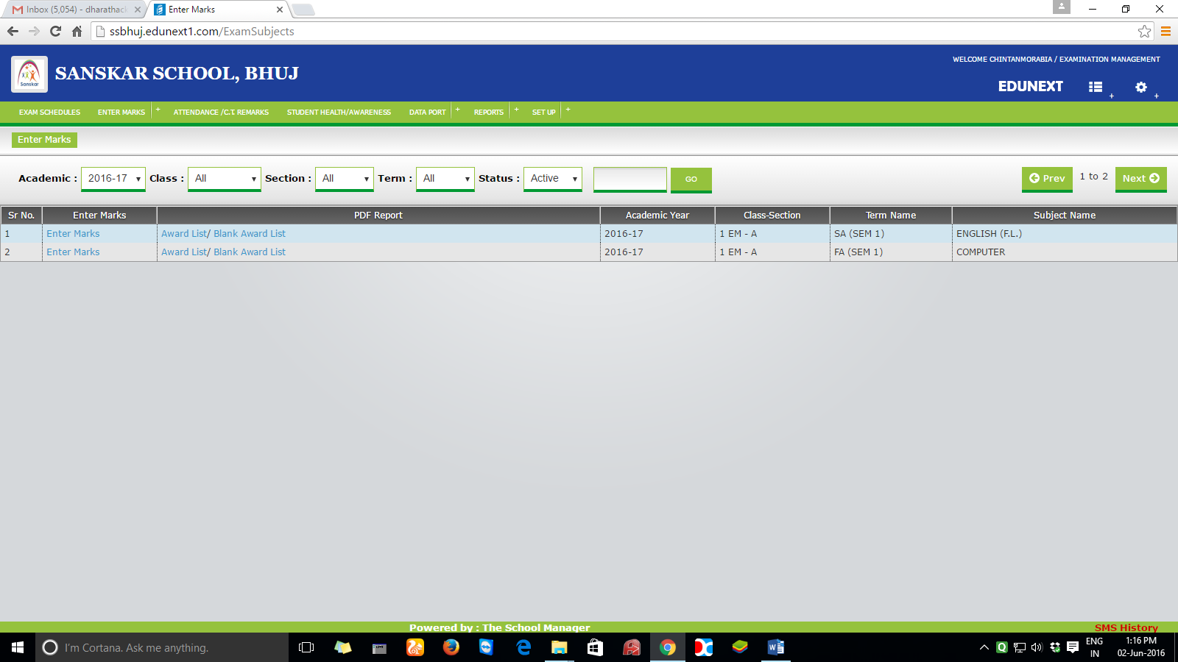

Enter Marks (blue coloured) : for terms except attendance

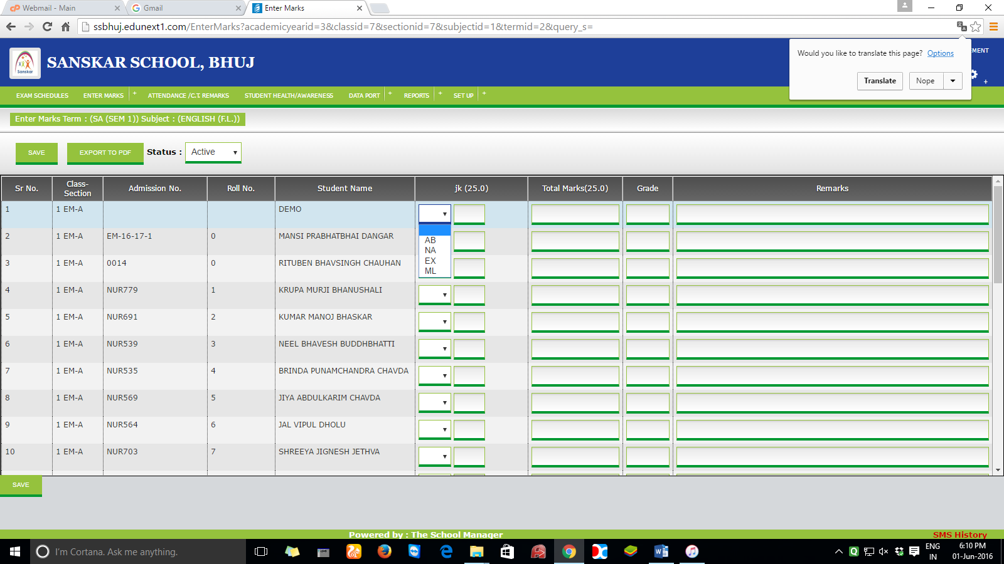

Combo box choice: AB, NA, EX, ML, OL

In the enter marks homescreen “award list/blank award list” is there.

Instead of that, we will require – “view/download” along with its icon.

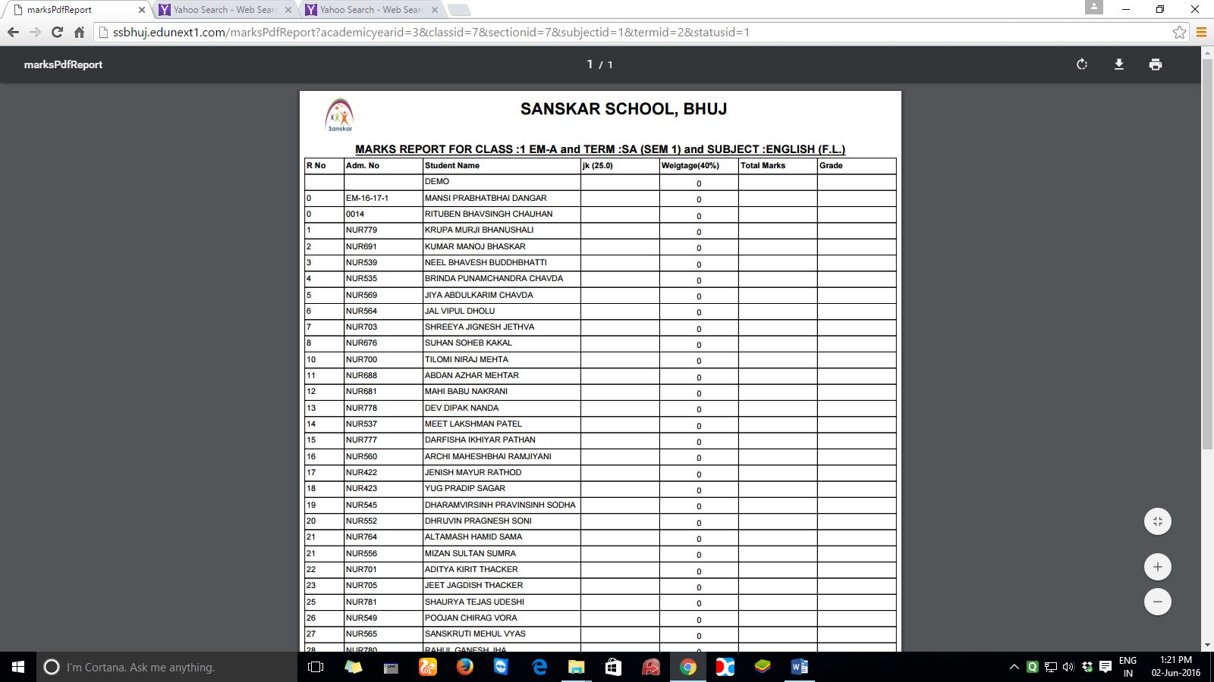

We will require the following fields

Sr. no, ID No., Student Name, activity name/activity names(not mandate),Total Marks, Obtained Marks

At the end of the report, we will require the following tags class highest, class average, no. of failures.

1. Generate attendance marks menu

In this option, we have to calculate marks of students of their attendance as per the below mentioned details

Academic year - as it is

Course: COMBO

Sem : combo

From date:

To date:

|  |  |
| --- | --- |
|  | Marks to be entered |
| >80 |  |
| 70-80 ( 70 to 79.99 ) |  |
| 60-70 ( 60.00 to 69.99 ) |  |
| 50-60 ( 50.00-59.99) |  |
| 40-50 ( 40.00-49.99) |  |
| 30-40 ( 30.00-39.99) |  |

**Max marks which can be entered is 5**

**Button- generate**

**This generate button will generate the marks internally in the table which will be utilised in the next option.**

Enter Marks (blue coloured): for term - attendance

In this menu, we need to generate the marks of the students as per the above generated format.

Academic year - as it is

Course : COMBO

Sem : combo

Div : combo

From date :

To date:

**By clicking the button GENERATE, following list will be displayed below**



Fields will be required – sr. no, sem-div,id no,student name,marks(5),remarks

Data of marks should be populated from the Generate attendance marks menu which can be editable also. If the marks are edited, remark should automatically writtern as “modified marks”

1. Verify marks :

Note : marks entry of the terms except attendance will be done twice, once from the faculties login and once from the admin person login. Reason behind this is to omit the typing mistake and to cross check the marks as its very critical. After a subjects marks are entered from two different users, it must be cross verified and it should generate the errors if a particular students marks are getting varied in a particular term.

Below is the flow for this which should only be active for the upper level management persons and which only get activated when marks are entered by admin and a faculty both.

Academic year:

Course:

Sem :

Div :

Subject name:

Term: ( e.g.unit test, internal test, assignment, presentation etc.)

Button --🡪 show

This will show marks of both admin person and faculty in an adjacent way student wise.

Sr. no. , course, sem, div, subject name, term name, marks 1 (faculty),marks2(admin), tag(ok(green),error(red))

If error(difference) is there in the marks of faculty and admin, it should be editable, edited marks should also reflect (overwritten) everywhere where its getting used. when all the marks proper without any differences than only it should be migrated to the next level.

1. Enter absent student marks :

In this option, students who are absent/O.L./M.L. for any of the terms, i.e. unit test, internal test, assignment, presentation, marks entry of those students will be done.

Course:

Sem :

Div :

Subject name:

Term: ( e.g. Unit test, internal test, assignment, presentation etc. Except attendance )

Button --🡪 show

Following list shall be generated.

Sr.No, ID No, Name, Reason, Max Marks, Obtained Marks

1. Assign University Seat Numbers:

Academic year:

Course:

Sem :

Button--🡪 Generate

After generate, the following view will be displayed with the titles as described

Sr. No, Course-sem-div, student name, id no, university seat number( to be entered)

Button--🡪 save, save&download (pdf)

1. UNIVERSITY INTERNAL MARKS ENTRY:

Academic year:

Course:

Sem :

Div :

Subject name:

List will be populated as per below mentioned details:

Sr. No., course-sem-div,id no,Student Name,University Seat No,term1,term2,term3…, total(),pass/fail

Except unit test and internal test marks, other terms marks should be editable and it shall reflect simultaneiously when edited with pass/fail.

Button-🡪 save

1. Block arrangement

In this module, we want to design the arrangement of blocks in our exams. A block can contain multiple course students ( B.B.A-B.C.A.) and / or students from same course but different semesters.

Block label: (text box) : e.g. A : TYBCA-1

Block capacity: (number input): e.g. 60

Date : ( user can enter multiple dates if block arrangement is same for multiple days )

Academic Year :

Exam Name : radio button : theory practical

Stage / white board

|  |  |  |  |  |  |  |  |  |  |
| --- | --- | --- | --- | --- | --- | --- | --- | --- | --- |
| 15bca001 |  |  |  |  |  |  |  |  |  |
|  |  |  |  |  |  |  |  |  |  |
|  |  |  |  |  |  |  |  |  |  |
|  |  |  |  |  |  |  |  |  |  |
|  |  |  |  |  |  |  |  |  |  |
|  |  |  |  |  |  |  |  | 15bca030 |  |

Assume one cell above as one student. One set of blue and white cell is one bench

I.e. operator has selected 15bca001 in the cell 1 than other cursors will show the number which can be there at a particular cell. i.e. at last cell if we click than it will show 15bca030 assuming that all the id numbers are in sequence.

Save

Reports:

1. Block summary report

This report is to be put on the notice board. If block arrangement is same for multiple days, the report will be the same. If not, it will be different from day to day.

Dashboard : ( dashboard for all the reports will be of this kind, fields will get vary )

Check box Sr. No Exam Name Date ReportType Academic Year No. of Blocks Total Students

1 unit test 1/1/16 block Summary / 2016-17 7 450

Block arrangement report /

Senior Supervisor report /

Junior supervisor report /

Examiner Report

Check box should be there to generate more than one date’s report together.

Top selection fields, instead of academic year class etc…

Academic year from date to date go

REPORT : block summary report : ( one copy will be generated which will summarise all the blocks )

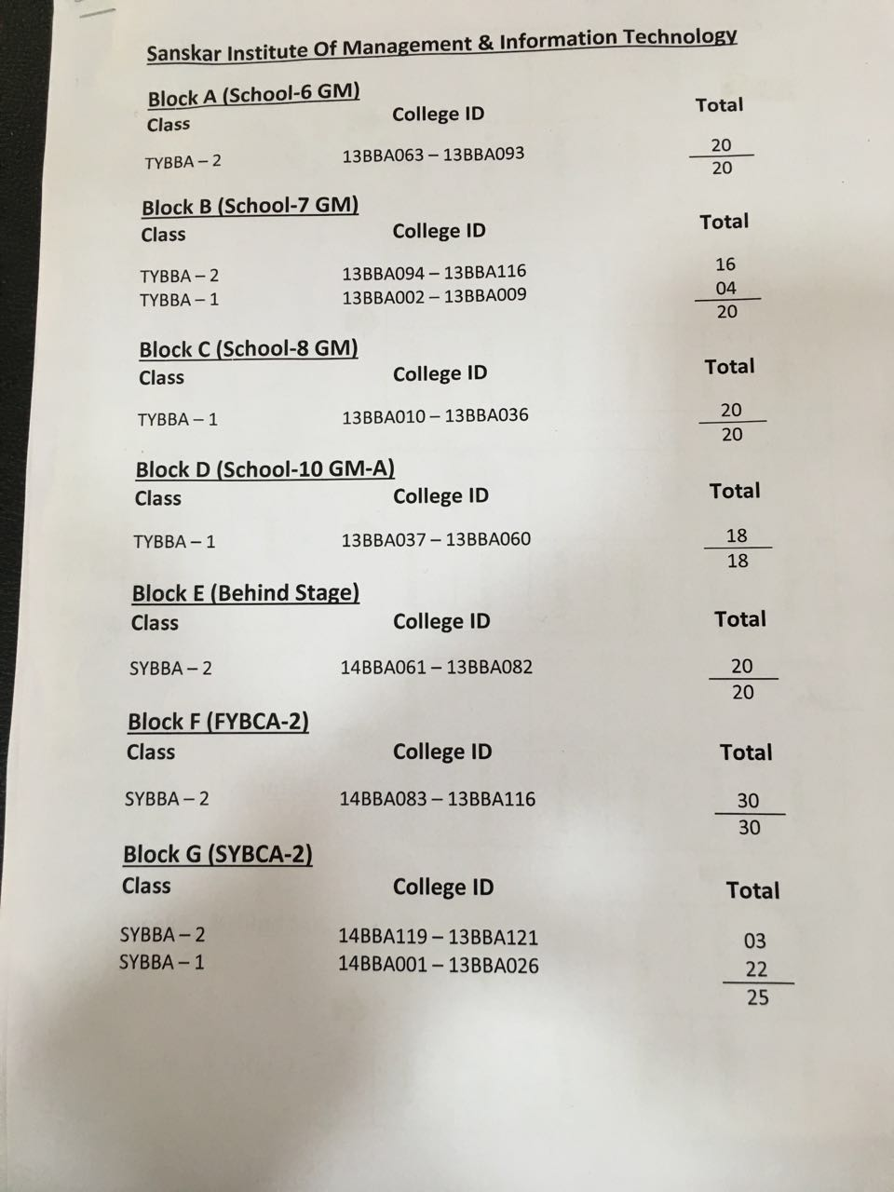

ACADEMIC YEAR AND EXAM NAME TO BE ADDED ON THE TOP BELOW THE COLLEGE NAME

REPORT 2 : BLOCK arrangement report ( separate copy for each block. If 7 blocks are there than 7 pages of a report )

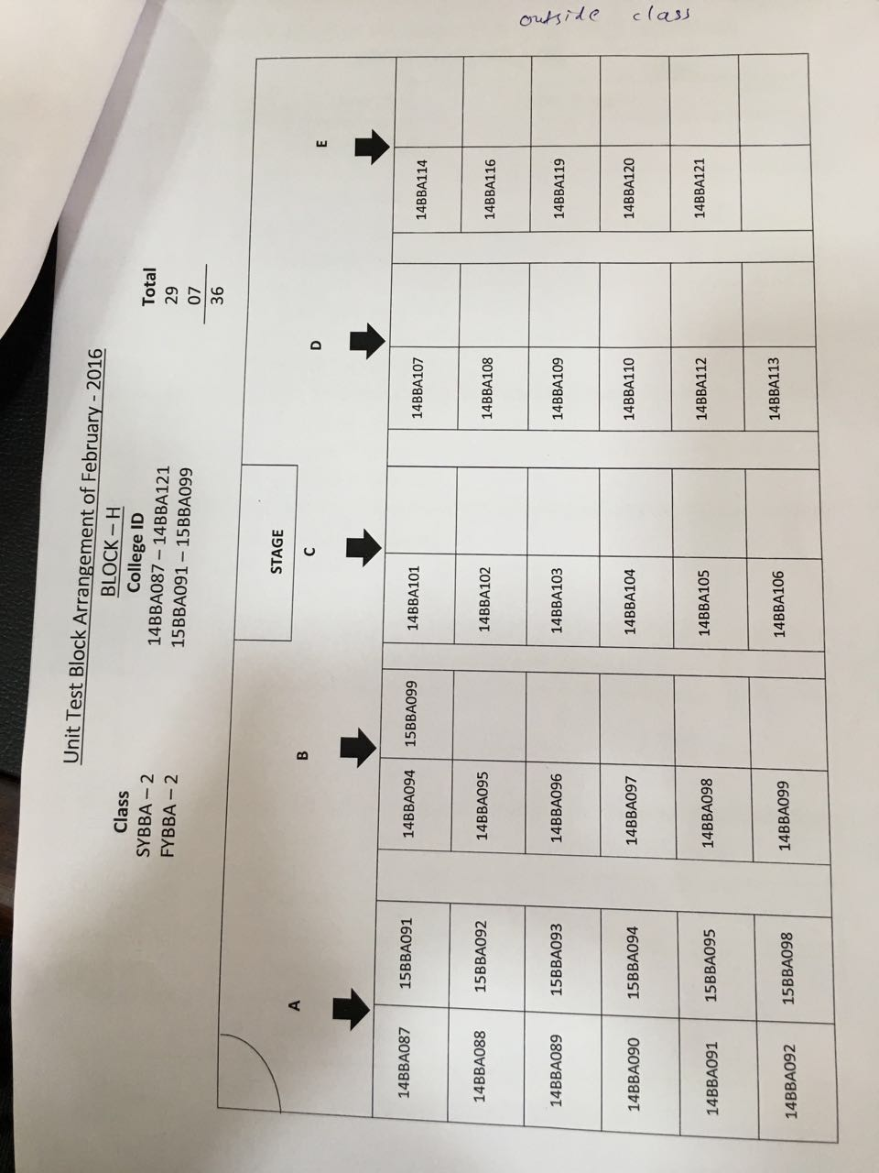

College name in the heading and date to be added

Report: Senior Supervisor Report (students class centric report. one copy. If total 11 classes are there than 11 sections will be there in a report which will show where the students are sitting of a particular class )

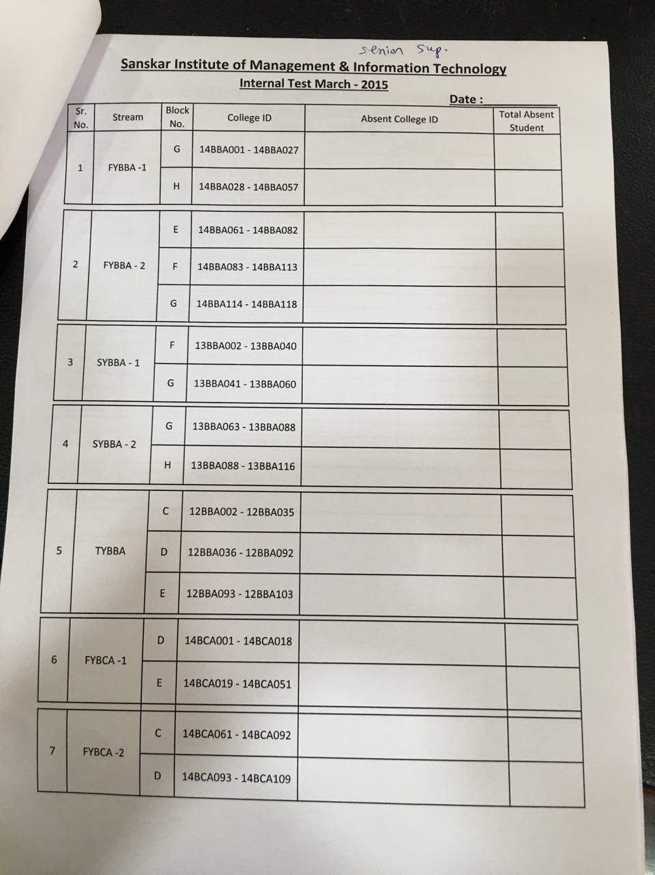

Report : Junior Supervisor Report ( this report will be block wise. If in block A , students of 3 different classes are sitting than total 3 pages will be there of a particular block. If total 7 blocks are there and in each block students of 3 different classes are sitting than total 21 pages’ report will be generated.

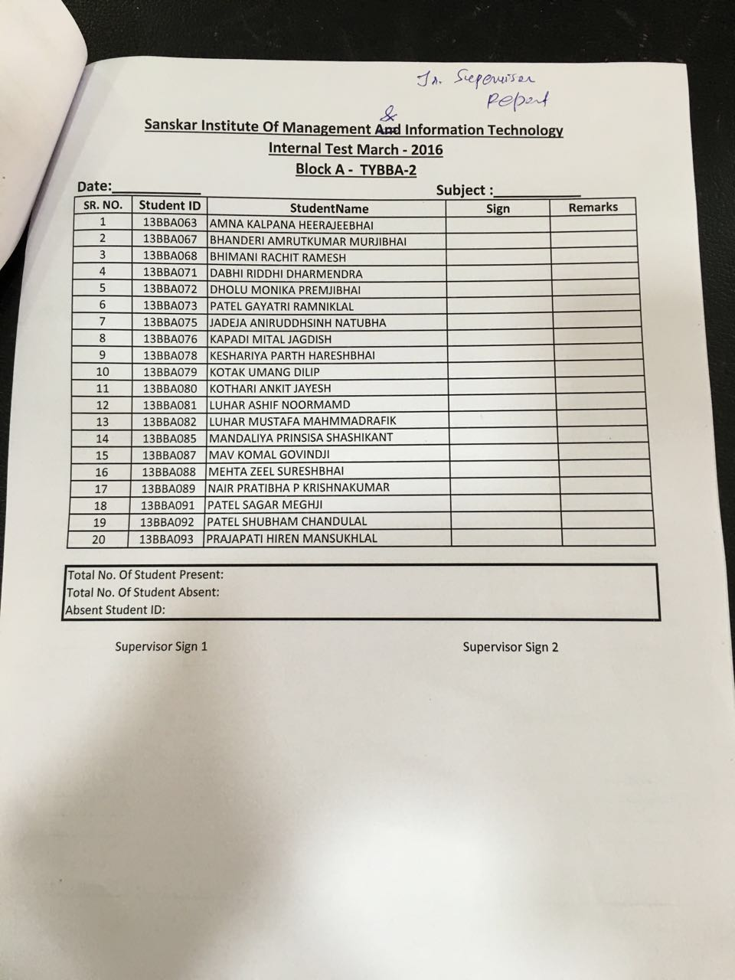

Report : Examiner Report. same as above report with few minor additions.

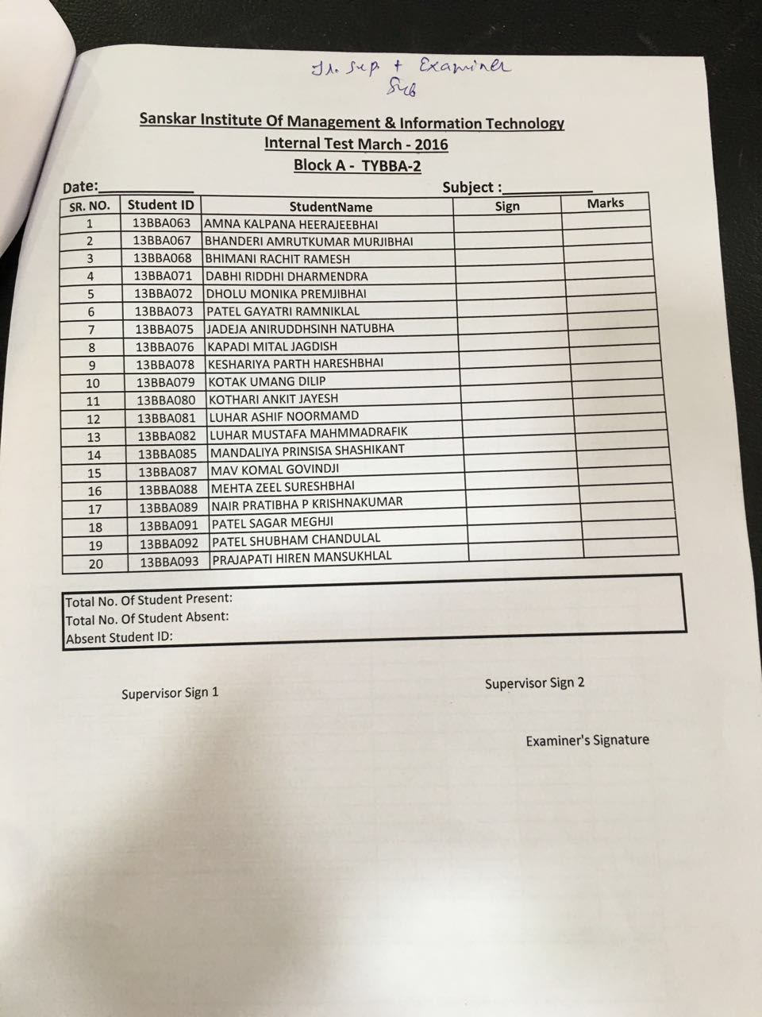

For practical exams :

